**QUALITY ASSURANCE DASHBOARD**

A Capstone Project Presented to the

Faculty of Engineering-Computing Academy of Science and Technology

Panpacific University

In Partial Fulfillment

Of the Requirements for the Degree of

Bachelor of Science in Information Technology

In Partial Fulfilment

Of the Requirements for the Degree

BACHELOR OF SCIENCE

INFORMATION TECHNOLOGY

By

Kierstan Seigheart Parel

Jimson Luis Duque

Lyndon John D. Pablo

DECEMBER 2024

**APPROVAL SHEET**

This capstone project entitled “WEBSITE DASHBOARD QA” prepared and submitted By:

Kierstan Seigheart Parel, Jimson Luis Duque Lyndon John D. Pablo

in partial fulfillment of the requirements for the degree of

**Bachelor of Science in Information Technology**, has been examined and is

recommended for acceptance and approval.

**JANE M. FERNANDEZ DIT.**

Adviser

**APPROVED BY**

**Theresa Tantay Limos Armie Quizon Valencia**

Panel Evaluator Panel Evaluator

Accepted as partial fulfillment of the requirements for the degree of

**Bachelor of**

**Science in Information Technology.**

**JANE M. FERNANDEZ, DIT**

Dean, School of Engineering-Computing Academy of Science and Technology

**DECLARATION OF ORIGINALITY, CONFLICT OF INTEREST AND FUNDING**

This capstone project is original and has not been submitted for another degree. All sources used in this project have been properly acknowledged or properly cited.

The authors declare that there is no conflict of interest in this capstone project. The authors have not received any funding from any source in the course of completing this capstone project.

Kierstan Seigheart Parel

Jimson Luis Duque

Lyndon John D. Pablo

**ENGLISH EDITORIAL CERTIFICATE**

This is to certify that the undersigned has thoroughly reviewed and gone through all

the pages of the manuscript of the research project detailed below and has found it

acceptable with respect to grammatical rules governing proper English language

composition.

**Name of Researchers:**

KIERSTAN SEIGHEART PAREL

JIMSON LUIS DUQUE

LYNDON JOHN D. PABLO

**Program:**

BACHELOR OF SCIENCE INFORMATION TECHNOLOGY

**TABLE OF CONTENTS**

TITLE PAGE ………………………………………………………………… i

APPROVAL SHEET ………………………………………………… ii

DECLARATION OF ORIGINALITY, CONFLICT OF INTEREST

AND FINDING ……………………………………………………… iii

ENGLISH EDITORIAL CERTIFICATE …………………………………… iv

ACKNOWLEDGEMENTS ………………………………………………… v

TABLE OF CONTENTS …………………………………………………… vi

List of Tables ……………………………………………………………… viii

List of Figures……………………………………………………………..... ix

CHAPTER 1: INTRODUCTION ………………………………………… 1

Project Overview …………………………………………………….….... 1

Background of the Study………………………………………………… 2

Description of the Project……………………………………………… 3

Statement of the Problem……………………………………………… 3

Conceptual Framework ……………………………………………… 4

TECHNICAL BACKGROUND ………………………………………… 5

Software …………………………………………………….….... 5

Hardware …………………………………………………………….. 5

Scope and Limitation…………………………………………………… 6

CHAPTER 2: METHODOLOGY …………………………………… 7

Research Design ………...…………………………………………… 7

Software Development Methodology …………………………………… 9

Source of Data ………………………………………………………………. 10

Data Gathering Techniques …………………………………………….… 10

Data Gathering Tools …………………………………………………….... 10

Ethical Considerations …………………………………………………..... 11

Treatment of Data …………………………………………………….….... 11

**LIST OF TABLES**

Table_No. Title Page

1 Paradigm of the Study ............................................................................ 5

2 Software Requirements ........................................................................... 6

3 Hardware Requirements .......................................................................... 7

**LIST OF FIGURES**

Figure No. Title Page

1.Agile Methodology …….……................................................................. 10

**DASHBOARD QA**

**Kierstan Seigheart Parel**

**Engineering-Computing Academy of Science & Technology, Panpacific University**

**Rosales, Pangasinan**

**kierstanseigheart.parel@panpacificu.edu.ph**

**Lyndon John B. Pablo**

**Engineering-Computing Academy of Science & Technology, Panpacific University**

**San Manuel, Pangasinan**

**lyndon.pablo@panpacificu.edu.ph**

**Jimson Luis Duque**

**Engineering-Computing Academy of Science & Technology, Panpacific University**

**Pinmaludpod, Urdaneta City, Pangasinan**

**@panpacificu.edu.ph**

**PROJECT OVERVIEW**

The Website Dashboard project aims to develop a dynamic, responsive platform for real time data Monitoring, management, and interactive posting functionality, reviewing, and verifying data such as activity logs, updates and key metrics. A structured approval system will be implemented. It will integrate Seamlessly with external databases, ensuring up to date and accurate information for users. Designed for both staff and administrators, the dashboard will ence data consistency, transparency, and accountability by indicating the status of each update.

With an intuitive, user friendly interface the dashboard will allow customizations based on user roles and preferences making data easily accessible and actionable. Users will be able to track performance, identify trends and make informed decisions efficiently. By fostering collaboration and streamlining workflows, the platform will improve operational efficiency, ensure data integrity, and support a proactive, well informed organization

Page 1

**BACKGROUND OF THE STUDY**

In today's data-driven world, educational institutions require efficient and reliable systems to manage, monitor, and analyze critical information in real time. The increasing complexity of academic operations, coupled with the need for timely and accurate data, highlights the importance of a dashboard system that seamlessly integrates with school databases and provides real-time insights (Baker & Inventado, 2014; Daniel, 2012).

The Website Dashboard project aims to address these challenges by developing a dynamic, responsive platform that allows users to interact with key data efficiently. The dashboard will serve as a centralized hub where teachers and administrators can post real-time updates on academic activities and other school-related information. This structured approach enhances transparency, accountability, and collaboration within an educational institution, ensuring that only verified and accurate data is displayed (Romero & Ventura, 2020; Siemens & Long, 2011).

One of the significant challenges in modern educational data management is ensuring data integrity and accuracy while maintaining ease of use. The proposed dashboard will feature a built-in verification process, where submitted updates undergo review by authorized personnel before being published. This mechanism ensures consistency and prevents the dissemination of inaccurate information. Furthermore, the ability to track approval statuses enhances operational clarity, making it easier for users to understand the workflow of data submission and verification (Ferguson, 2012; Piety, 2013).

Another essential aspect of the project is its user-friendly interface, designed to accommodate users. By integrating intuitive navigation, the Website Dashboard will provide an inclusive and seamless user experience, allowing users to tailor the platform to their specific needs (Norman, 2013; Nielsen, 1994).

The demand for real-time data visualization has become increasingly prevalent in educational institutions. Schools and universities require agile and responsive solutions that allow them to adapt quickly to changes, identify student performance trends, and make informed academic and administrative decisions. By offering real-time data synchronization, the Website Dashboard will enhance educational efficiency and ensure continuous access to the most relevant and updated information (Verbert et al., 2013; Yassine, Kadry, & Sicilia, 2016).

This project aligns with United Nations Sustainable Development Goal (SDG) 4: Quality Education, which emphasizes the importance of inclusive and equitable education and the promotion of lifelong learning opportunities for all. By providing a modern and efficient data management tool, the Website Dashboard contributes to digital transformation in education, enhances productivity, and supports informed decision-making, ultimately strengthening institutional resilience and efficiency (United Nations, 2015).

In summary, the Website Dashboard project is designed to bridge the gap between real-time data management and usability in an educational setting. By integrating features such as seamless database connectivity, real-time updates, data verification, and a user-friendly interface, this platform will serve as a vital tool for enhancing decision-making processes and fostering a more collaborative and transparent academic environment. The development of this system will ultimately contribute to more streamlined school operations, improved accountability, and a more efficient approach to managing critical educational data.

Page 3

**DESCRIPTION OF THE PROJECT**

The Website Dashboard is a web-based platform designed to streamline data management and real-time monitoring within educational institutions. This system provides a centralized interface where administrators, teachers, and other authorized personnel can efficiently manage academic activities, and oversee school-related updates.

Designed with usability in mind, the dashboard features an intuitive interface that accommodates users with varying levels of technical expertise.

**Statement of the Problem**

The purpose of this study is to assess the effectiveness of the Website Dashboard in managing real time data in Panpacific University. The research aims to answer the following questions:

1. What is the current process of monitoring documents evidence for accreditation (ISO,QS, etc.)?
2. What are the problems encountered in the current system?
3. What features should the Website Dashboard have to improve usability and accuracy?
4. What is the level of acceptability of the proposed system?

Page 4

**CONCEPTUAL FRAMEWORK**

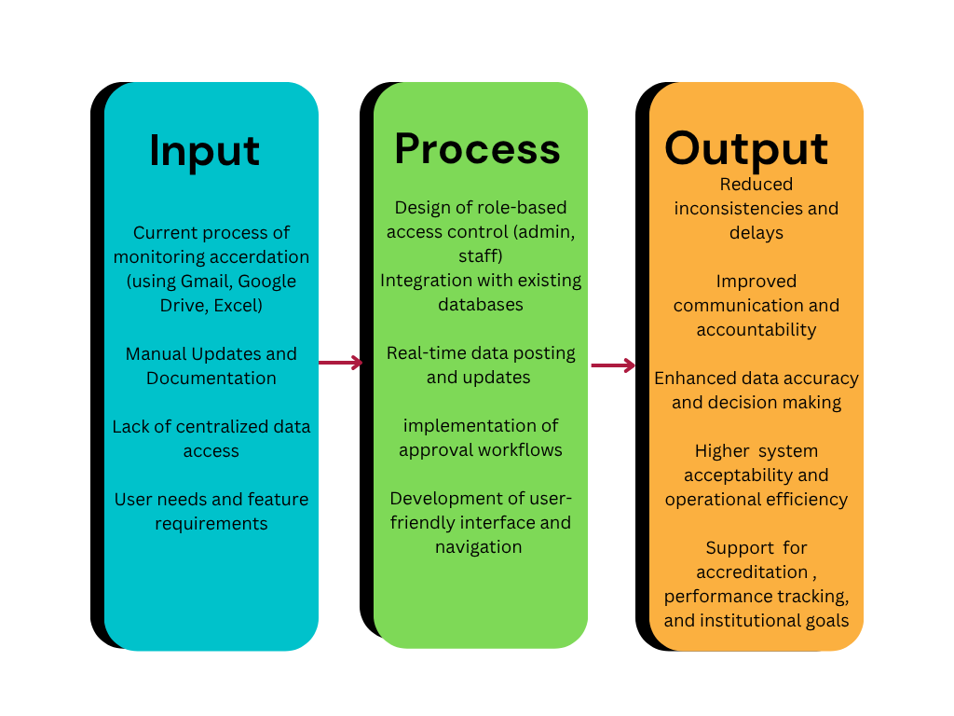

**Figure 1.** Research Paradigm Model Showing the Interpretation ofWEBSITE DASHBOARD QA

The existing process of monitoring accreditation is based on Gmail, Google Drive and manual updates of Excel, which causes inconsistencies, delays, and miscommunication. To deal with this, the suggested Website Dashboard offers a central to handle accreditation data.

The platform has a role-based access control allowing the staff and administrators to publish, view, and approve the forms of activity logs. A centralized authorization process would make it precise and accountable, and database integration would make all the difference where manual tracking would be replaced by real-time updates. The dashboard would allow us new features of user friendliness and monitoring of performance hence it will increase the effectiveness of teamwork, decision making and efficiency when compared to the existing manual process.

**TECHNICAL BACKGROUND**

The Website Dashboard project operates with multiple technological tools which enable educational institutions to observe and analyze essential data points in live situations.

The development tools consist of VS Code and React.js and MongoDB provides the data storage system and GitHub controls project teamwork.

The cloud server hosts the platform accessible through laptops and desktops which connect to the internet. Secure storage with SSD technology combined with firewall protection will provide clients with optimized access.

Real-time information is presented through a dashboard containing an interactive design which also maintains accurate data by performing verification procedures. The administrator and teaching staff will submit content updates that require verification before they go live on the platform. The implemented system will optimize school data management through operation streamlining and decision-making improvement along with collaboration strengthening.

**Technical Background**

Table 1:A.

**Software Requirements**

**Software**  **Description**

|  |  |
| --- | --- |
| VS Code | This code editor functions both as a frontend and backend development tool for lightweight powerful programming. |
| React.js | The tool builds the website interface that delivers a contemporary and interactive design. |
| MongoDB | The system holds essential school information in a secure database structure. |
| GitHub | The system provides an effective management platform for colleagues to access and organize project files together. |

Table 2. Hardware

**Hardware Requirements**

**Hardware**  **Description**

|  |  |
| --- | --- |
| Cloud Server | A computer in the cloud with enough power to run the website 24/7. |
| Laptop/Desktop | Any computer that can access the website through a web browser. |
| Internet Connection | A stable connection to ensure smooth access and real-time updates. |
| SSD Storage | Fast storage to keep the website running quickly and efficiently. |
| Firewall & Security | The website remains secure against unauthorized hackers through protection mechanisms. |

Page 6

### **Scope and Limitations**

**Scope:**The Website Dashboard is particularly designed to assist Panpacific University staff and administrators in monitoring and managing academic activities and institutional information in real-time. The system serves as a central platform where posts of academic updates, monitoring of submissions, and the authentication of information prior to publication by authorized users are possible. It is crafted to aid in data accuracy, enhance operational transparency, and increase institutional efficiency. The dashboard is fully integrated with the internal database of the university and has a friendly interface through which data interaction and navigation are easy and efficient. Real-time synchronization functions are also provided in the dashboard to provide the latest information to the users at any time.

**Limitations:**Although the Website Dashboard is highly advantageous, it also has a few limitations. It can only be accessed by authorized university staff, and hence, it cannot be used by the common people or extraneous stakeholders. The platform depends greatly on prompt entry of data and timely approval of submissions in order to keep it operative. It also needs a fast and consistent internet connection to ensure real-time updation and synchronization of data. Finally, the dashboard is specifically designed for internal operations within the university and is not intended to be used in institutions or outside environments.

Page 7

**CHAPTER 2**

**METHODOLOGY**

The research examines the Website Dashboard in Panpacific University through qualitative methods to study its development process and implementation along with its effects on the university. Qualitative research methods allow researchers to investigate system implementation alongside the evaluation of user encounters and operational issues concerning real-time academic data management. User perception analysis along with their interactions and feedback collection will enable identifying subsystem weaknesses to guarantee the dashboard provides the required features for personnel and administrators at Panpacific University. This research looks into how the system utilizes modern data access methods for achieving transparent data while ensuring accuracy and real-time availability which facilitates improved institutional efficiency. This study uses qualitative research methods to acquire complete information about how the Website Dashboard functions as well as how effectively users can utilize it.

**RESEARCH DESIGN**

The research adapts a qualitative approach since it analyzes operational and rationale dimensions of the Website Dashboard's performance and user interface. Descriptive research enables researchers to conduct deep assessments that evaluate system capabilities and determine user contentment as well as system enhancement options.The researcher will obtain data by conducting interviews as well as focus group discussions together with direct observations of university staff members who contact the system. This set of methods will serve to evaluate how user-friendly and efficient the Website Dashboard is in addition to testing its real-time functionality Qualitative data collection serves as the research foundation to deliver valuable findings that will help enhance system capabilities and achieve operational success for the university’s data management requirements.

Page 9

**SOFTWARE DEVELOPMENT METHODOLOGY**

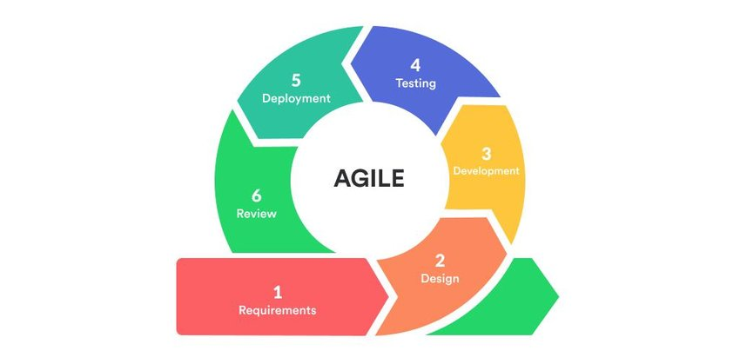

### **1. Requirements**

**Definition:** This phase involves identifying and documenting what the system must do to meet user and business needs.

**Explanation:**

**Key features** such as core functionalities (e.g., dashboards, reports, or login systems) are defined.

**Stakeholder input** is gathered through meetings, surveys, or interviews to ensure the solution addresses real needs.

**Security and scalability** requirements are set early to guide future design and development. For example, planning secure login methods or the ability to handle increasing user traffic over time.

### **2. Design**

**Definition:** This phase translates the requirements into a blueprint for building the application.

**Explanation:**

The **user interface (UI)** is designed using **React.js**, allowing for interactive and responsive web pages.

A **MongoDB database schema** is created to define how data is stored, structured, and related.

**User access levels** (e.g., admin, editor, viewer) are defined to control who can see or edit specific parts of the system, ensuring security and role-based access.

### **3. Development**

**Definition:** This is the actual coding phase where the software is built according to the design.

**Explanation:**

**Validation** ensures that user inputs are correct (e.g., proper email format), while **approval workflows** allow for steps like review and confirmation before changes go live.

### **4. Testing**

**Definition:** This phase checks whether the software works as intended and meets the requirements.

**Explanation:**

**Performance tests** measure speed and responsiveness.

**Functionality tests** verify that all features work correctly.

Feedback is collected from users, and the system is refined to improve usability and fix any issues.

### **5. Deployment**

**Definition:** The software is released to a live or test environment for use.

**Explanation:**

The application is first launched in a **staging environment**, which mimics the real system but is safe for testing.

**Security measures** (e.g., HTTPS, access control) are double-checked.

The rollout is done **incrementally**, meaning features or user groups are added step-by-step to reduce risk and catch issues early.

### **6. Review**

**Definition:** This is the post-deployment phase for evaluating success and planning improvements.

**Explanation:**

**User feedback** is gathered through forms, surveys, or analytics.

Based on this input, the team **makes improvements**, such as fixing bugs or adding small features.

Ongoing **updates** are planned to keep the system secure, efficient, and aligned with evolving user needs.

**Figure 1. AGILE Methodology Model**

The development process adopts the Agile Model to perform software development through successive small developmental cycles. Agile provides adaptive capabilities which enable a system to evolve continuously after receiving immediate feedback from testing and assessment. The first phase concentrates on determining essential activities together with the objectives which will result in effective interactive dashboards for educational institutions. Design requires developers to create both the user interface architecture and the database framework. Users benefit from the combination of React.js and VS Code tools during this phase to develop wireframes and initial designs that provide effortless user experiences.

Creating the system includes implementing MySQL as the data storage solution alongside using GitHub for version control. Seamless integration of the database with built-in data verification tools and real-time data refresh will form the core features alongside several other functional elements. The developer implements frameworks with appropriate technologies during development to achieve system scalability as well as security compliance.

Each separate part of the system including real-time data updates, user interface response speed and database integration will receive testing for both performance quality and accuracy during the evaluation phase. Users comprising teachers plus administrators together with students will provide feedback to help evaluate whether the system effectively addresses their needs and enhances educational operations. The feedback will concentrate on three main areas consisting of system performance data accuracy and ease of use together with recommendations for improvement.The Agile methodology enables ongoing adaptations to the dashboard which will occur based on received feedback to guarantee a strong user-oriented interface

**Source of Data**

The main source of data was gathered through the responses of school staff (KINS personnel) during the interviews we conducted. The table below shows the number of respondents.

|  |  |
| --- | --- |
| **Respondents** | **No.** |
| Staff(KINS Personnel) | 5 |

**Data Gathering Techniques**

This study will make use of qualitative data gathering techniques to gain a deeper understanding of the current functioning and challenges within the system. By utilizing methods such as interviews, surveys, and focus groups, the research aims to gather insights from users and KINS personnel involved in the system. This approach will help identify pain points, user experiences, and areas for improvement. The goal is to analyze the qualitative data to better understand how the system is perceived, its effectiveness, and how it can be optimized to meet the needs of KINS more effectively.

**Data Gathering Tools**

The researchers will conduct a semi-structured interview to gain an understanding of the KINS web system. The semi-structured interview will be used to assess the current functioning of the system and identify any issues related to its use. The survey questionnaire will include evaluation criteria to measure the effectiveness and overall performance of the system, helping to pinpoint areas for improvement and enhance its usability within KINS.

**Data Gathering Process**

The proponents have developed and finalized the questionnaire. Next, they will identify KINS personnel to gather insights on the proposed topic by asking them the relevant questions and conducting a study based on their responses.

The proponents will also explain to the respondents the importance of their participation in the study, clarifying key terms to ensure that they fully understand their role. This will enable the respondents to answer the questionnaire with a clear understanding of their responsibilities as participants in the study.

**Ethical Considerations**

The proponents assure that the information collected from outside the campus is strictly for research purposes. We seek the respondents' consent prior to their participation in completing the questionnaires. Participation is entirely voluntary and not mandatory, as we emphasized that it depends on their availability.

To ensure the security of the respondents, we have taken measures to protect their sensitive information. We only request their opinions regarding the challenges faced by the automated plant watering system using Arduino Uno. Throughout the duration of this capstone project, the proponents have made privacy and security a top priority.

**Data Collected**

The information gathered for the study encompasses in depth data on the present process of monitoring document evidence for accreditation at Panpacific University, particularly on systems such as ISO and QS. It also captures opinion on issues and constraints encountered using the current monitoring systems. Furthermore, user preference and desired functionalities for the Website Dashboard were gathered to inform system upgrades. Lastly, the research assesses the degree of acceptability and satisfaction of administrators and staff towards the envisioned dashboard system for purposes of gauging its usability and effectiveness.

**Data Processing**

The KINS web system processes the collected user data and activity logs, comparing it against predefined criteria. If certain conditions are met, the system triggers relevant actions to address the issue, such as sending notifications or activating necessary functions. This real-time data processing ensures that the system responds promptly to the needs of KINS personnel, optimizing workflow and enhancing overall efficiency within the system.

**Data Storage**

The KINS web system utilizes a secure database to permanently store user information and system data. This database supports the storage of key user details, activity logs, and other important metrics. For enhanced functionality, a cloud-based storage solution can be used to ensure reliable data management, allowing for the long-term tracking and analysis of user interactions and system performance. This ensures efficient access to and management of data over time.

**Data Utilization**

The collected data allows the web system to make real time decisions, ensuring optimal resource allocation based on the current conditions within the KINS system. The system operates entirely on real time data from various sources, which is continuously monitored to trigger or deactivate specific functions, ensuring efficient use of resources and improving overall management within the KINS environment.

**Treatment of Data**

The aim of this research is to assess the effectiveness of the Website Dashboard in handling real-time data at Panpacific University. This study will concentrate on learning the current processes employed to track document evidence for accreditation (e.g., ISO, QS, etc.), determining the shortcomings of the current system, and learning what functionalities the Website Dashboard must have to enhance usability and accuracy. Finally, the research will examine how well the proposed system is received by its users based on their experience and opinions.

Page 11

**RESULTS AND DISCUSSIONS**

This chapter presents the results of the data gathered through the finalized questionnaire administered to selected KINS personnel. The responses were analyzed and interpreted by the proponents to provide answers to the research problems stated in the study.

The information gathered represents the views and opinions of the respondents on the subject matter proposed. These views were gained after the proponents informed the participants about the reason for the study and explained basic terms so that participants know clearly what they were participating in. The cooperation of the participants and educated answers assisted the proponents in deriving worthwhile conclusions from the real-life experiences and comments provided during the study.

**For the features of the proposed employee Quality assurance dashboard the**

**following are done by the proponents**

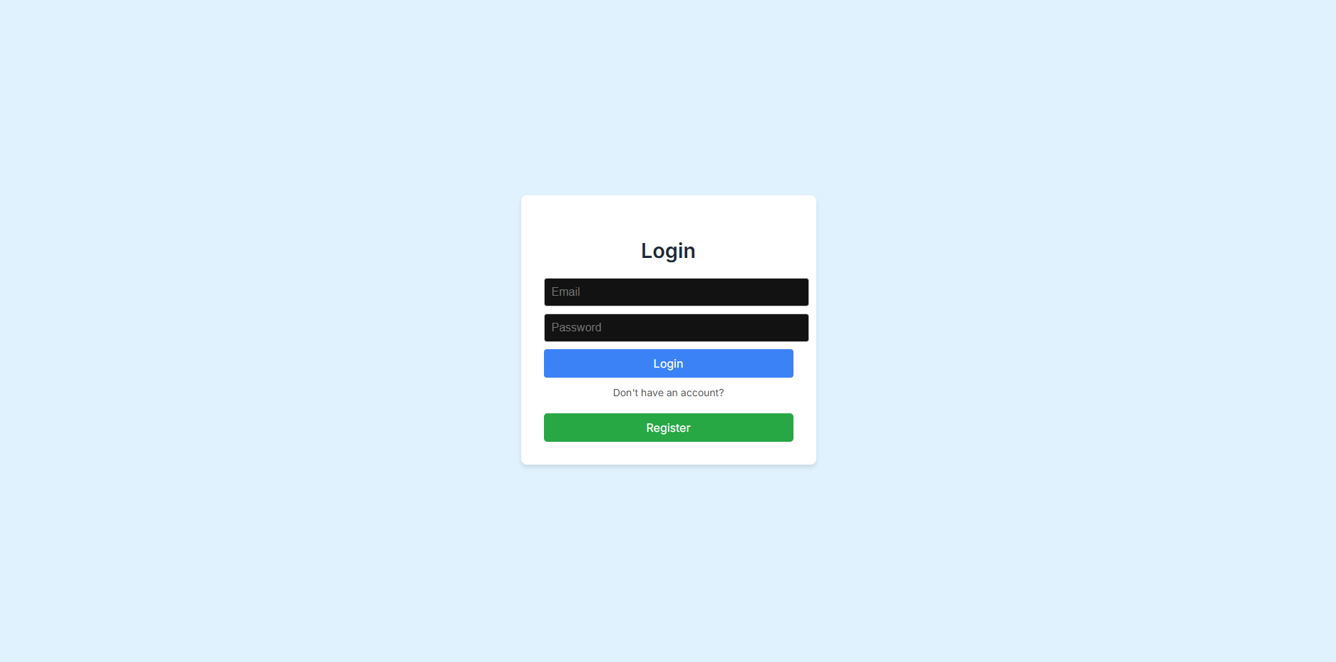

*Figure 3 Login Page*

**Dashboard(Admin)**

The figure (Fig.4) below shows the home screen of the Dashboard.

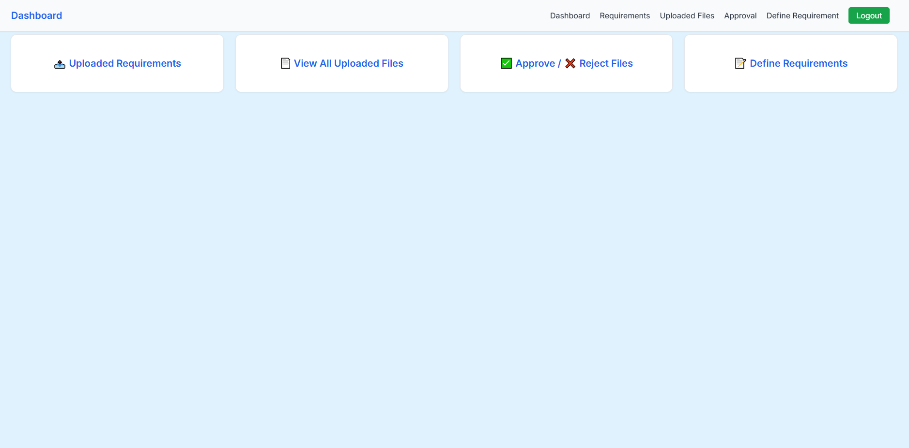

*Figure 4 Dashboard(Admin)*

**Define Requirements**

This is where the Admin will add the need requirements.

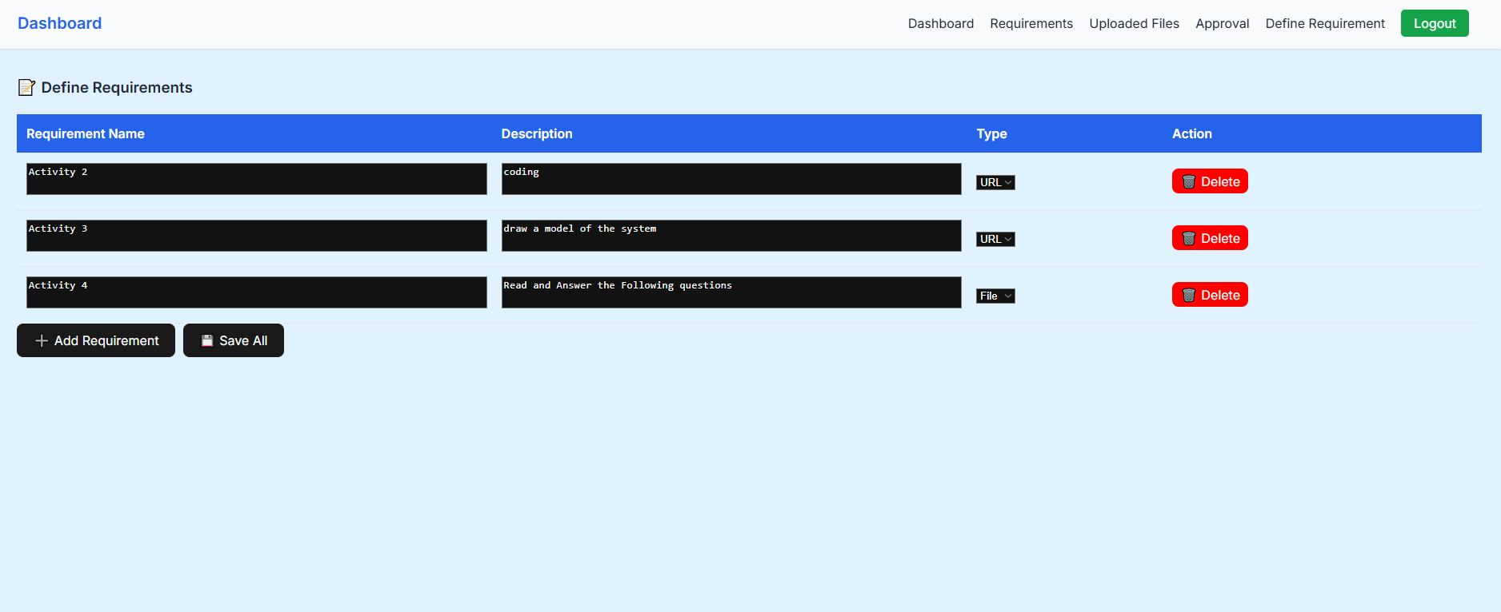

*Figure 5* Define Requirements

**Requirements**

This is where the Admin will see if the added requirements are uploaded.

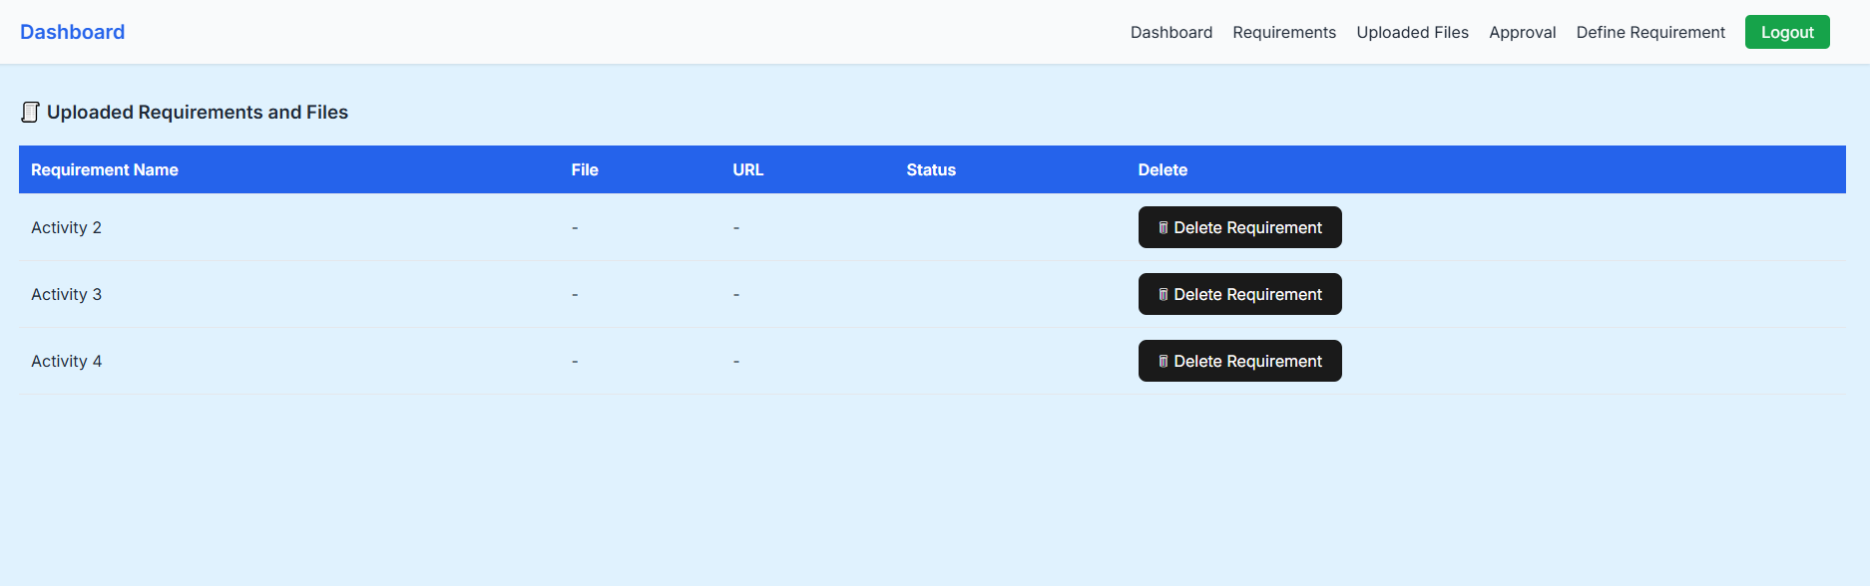

*Figure 6 Requirements*

**Uploaded Files**

This is where the Admin will see if the user uploaded files.

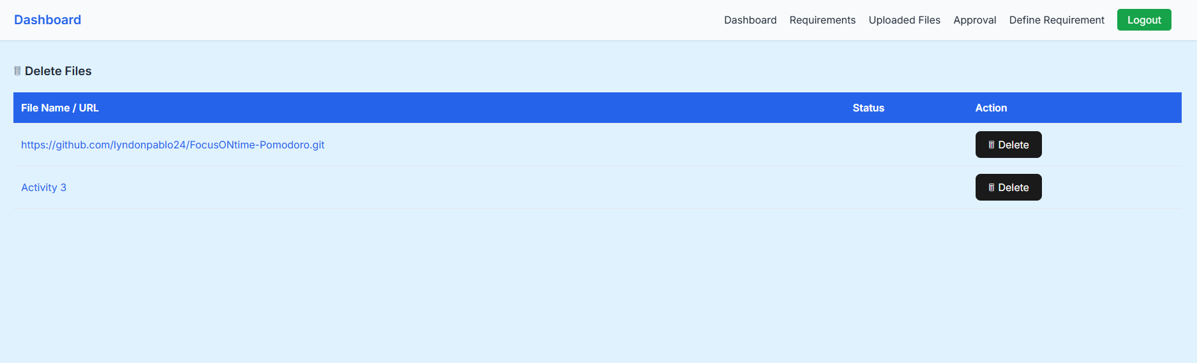

*Figure 7* Uploaded Files

**Approve And Reject Files**

This is where the Admin can view and approve and reject files.

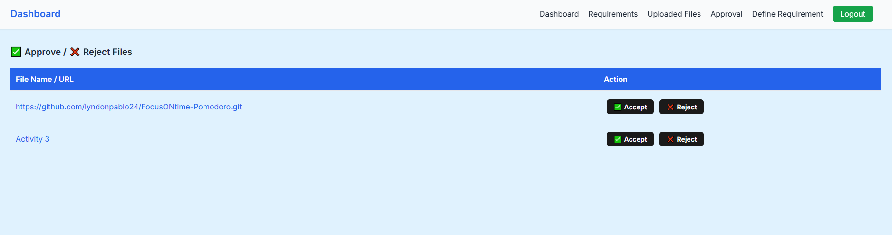

*Figure 8* Approve And Reject Files

**User Dashboard**

This is where the user can upload the needed requirements or files.

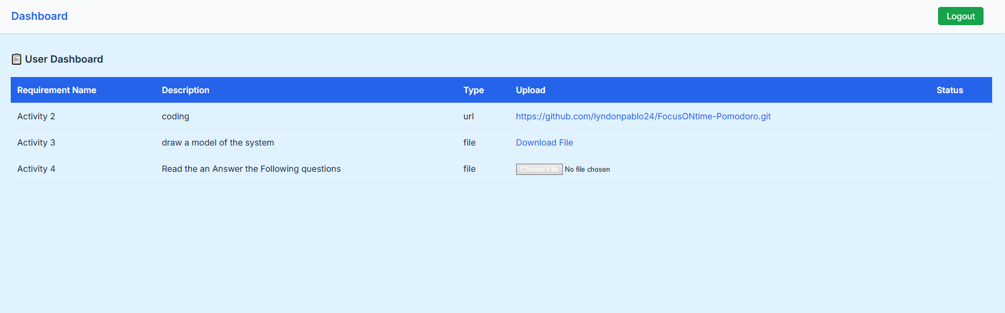

*Figure 9 User Dashboard*

**Data Dictionary**

Here It shows the files that have been uploaded.

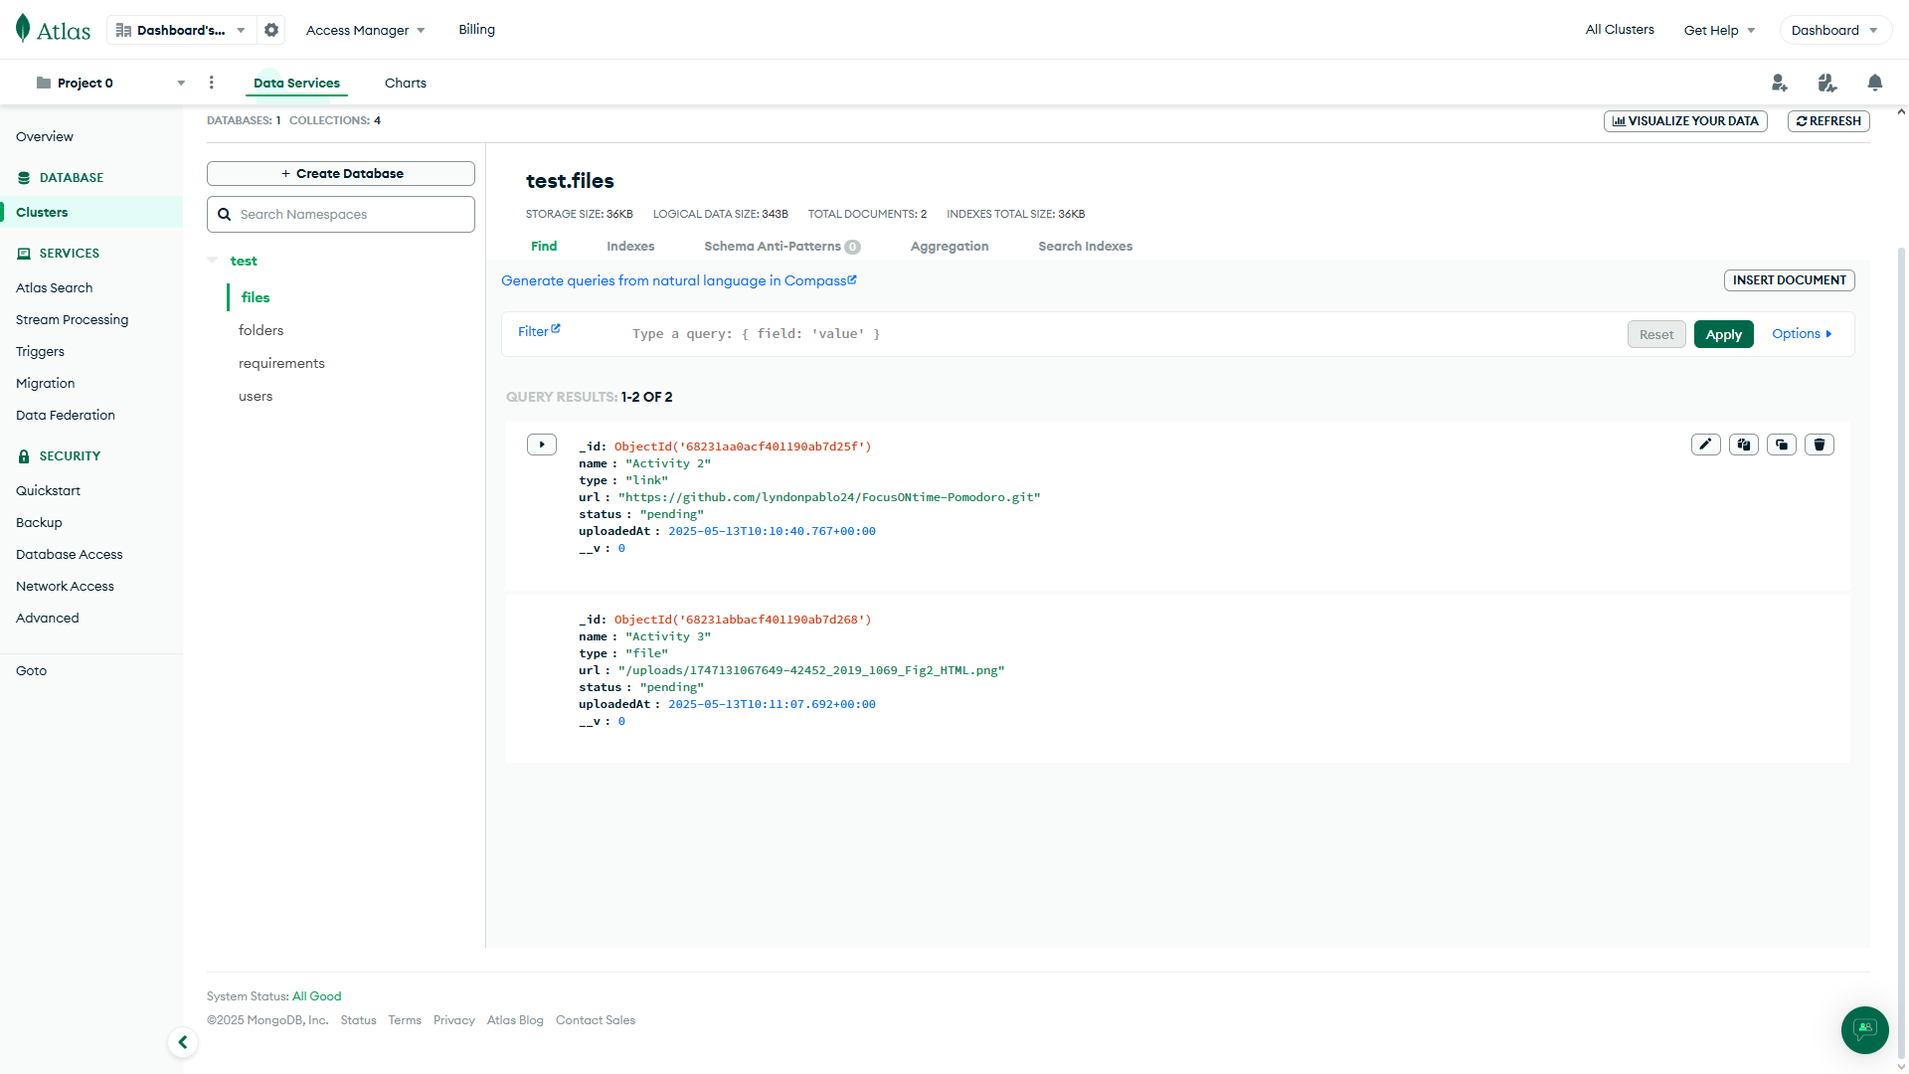

*Figure 10 Data Dictionary for files Management Database*

**Requirements**

Here is the requirements part this shows where the requirements are shown.

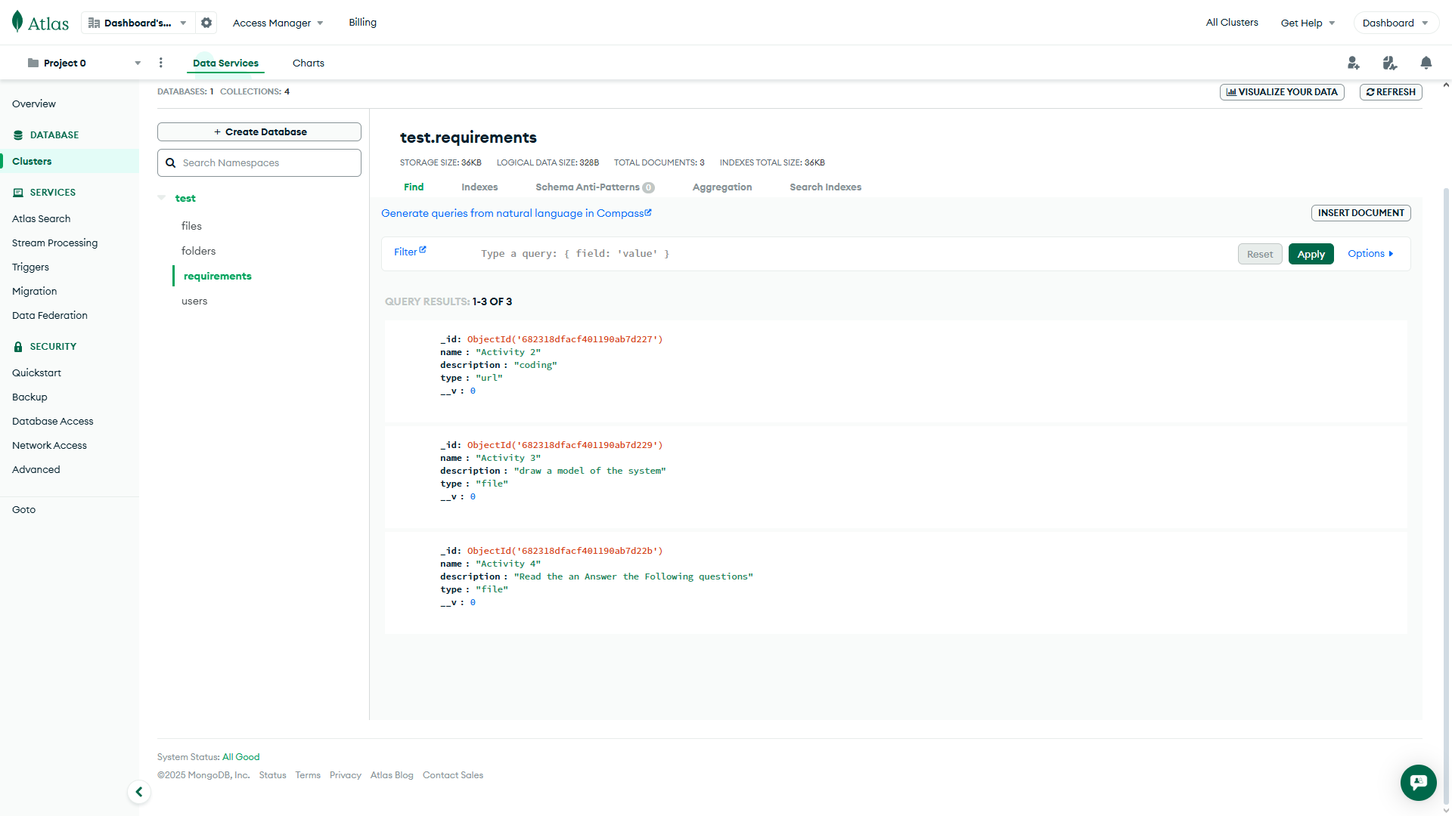

*Figure Data 11 Dictionary for requirements Management Database*

**Users**

The users show the email password role in the database making it easy to determine.

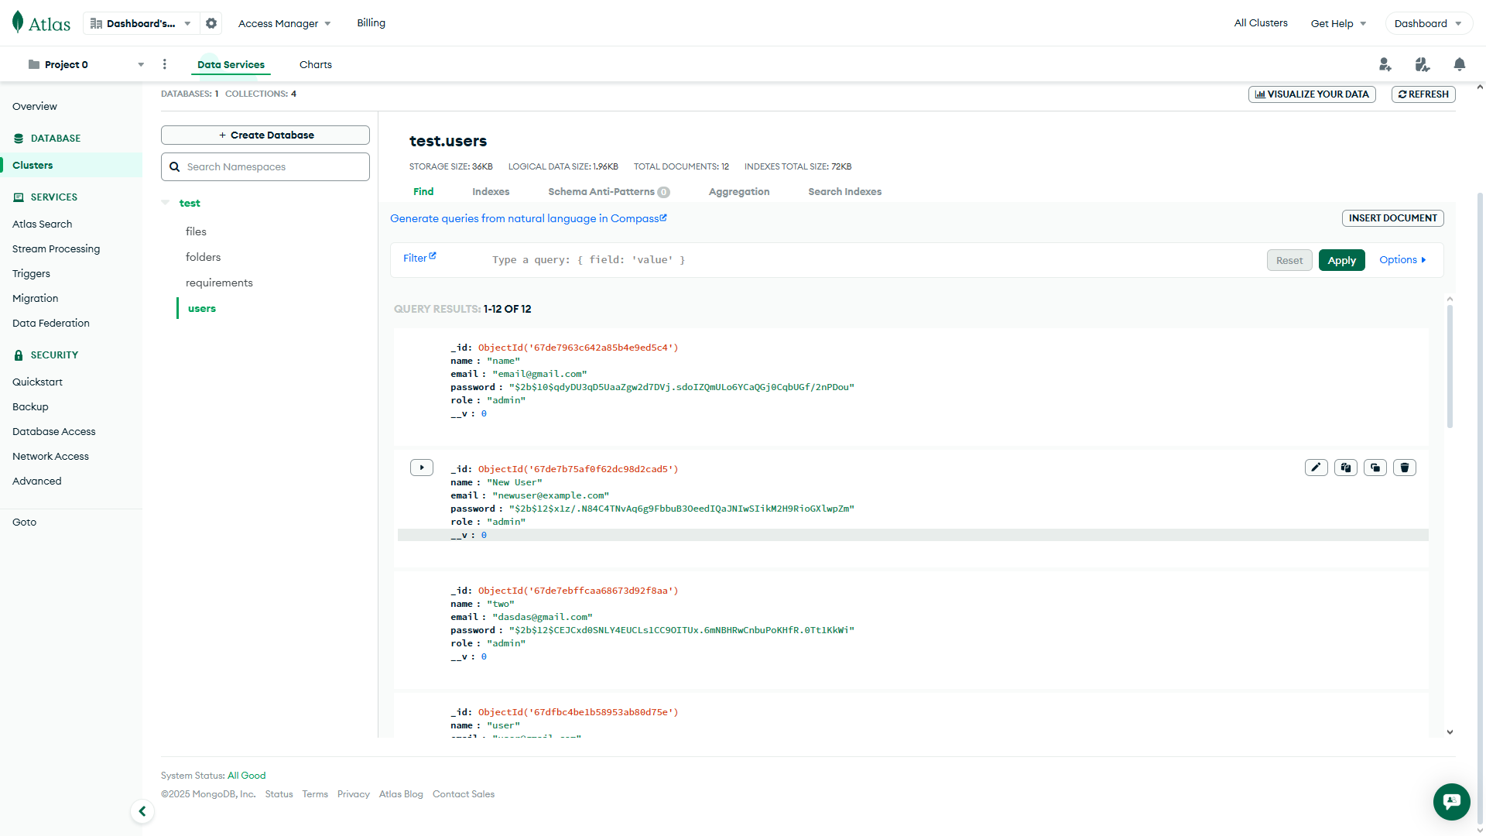

*Figure Data 12 Dictionary for Users Management Database*

**Requirement Specification**

To ensure the system performs efficiently and meets current technological standards, updated hardware and software specifications are necessary. The system should run on at least Windows 10 or Windows 11 to ensure compatibility with modern applications and security features. For hardware, a minimum of an Intel Core i5 (5th generation or newer) or an AMD Ryzen 5 equivalent is recommended. It should also have at least 8GB of RAM, with 16GB preferred for better performance, and a Solid State Drive (SSD) with a minimum of 256GB storage capacity. A full HD monitor, standard keyboard and mouse, and a stable internet connection of at least 10 Mbps are also required. Additionally, the system needs a user who can navigate and operate the interface with basic computer skills. While fast typing is not essential, the user should be capable of understanding and using the system properly. Meeting these specifications will help the system function smoothly and meet the institution’s expectations.

**Operational Feasibility**

Operational feasibility refers to how well the proposed system will function within the organization and how effectively it can be integrated into daily operations. Based on the study and user feedback, the system is considered operationally feasible. It addresses the current needs of the institution and is designed with a user-friendly interface that allows staff to navigate and manage tasks efficiently. Users are only required to have basic computer knowledge, which makes it easier for them to adapt to the system without extensive training. With proper orientation and minimal supervision, users can perform their tasks effectively using the system. The system also aims to reduce manual processes, increase accuracy, and improve overall productivity, making it a practical and beneficial addition to the institution’s operations.

**Use of available resources**Panpacific University already has the necessary resources to support the proposed system. The existing computers meet or exceed the minimum hardware requirements and can run the system without issues. The system is compatible with commonly used web browsers such as Firefox version 5.3 or higher, Google Chrome version 1.3.21.111 or higher, and Internet Explorer 7 or higher, all running on the Windows operating system. Additionally, the university’s current web hosting service can be used to upload the system, making it accessible online for employees. This allows the university to use its existing infrastructure without needing major upgrades, making the project practical and cost-efficient.

**Management Hierarchy**The shift from manual filing of leave to a paperless system should be smooth and easy for everyone to adapt to. Since management hierarchy is a sensitive part of the process, the system is designed to keep maintenance needs low. The Human Resources (HR) Office will continue to manage the daily operations of the system, just as they did with the manual process. If any technical problems happen, support will be available to assist. This setup keeps the system organized and ensures a clear line of responsibility without disrupting the existing structure.

**Use of Current Human Resources**

Panpacific University is already familiar with using technology to streamline its processes, as seen with the introduction of the computerized enrollment system. This familiarity will make it easy for staff to transition to using the new Website Dashboard, as the employees are accustomed to working with digital systems. Training on how to use the dashboard will be straightforward, ensuring that everyone can quickly learn how to navigate and manage the system. The proposed dashboard will not reduce the need for staff but will help them manage tasks more efficiently by allowing easy access to real-time data and performance metrics. With the system in place, the HR Office and management can easily monitor key metrics, track performance, and manage updates, leading to improved collaboration and decision-making. Therefore, the dashboard system will fit seamlessly into the university's existing processes, enhancing productivity without the need for major changes in staffing or operations.

**Technical Feasibility**The Website Dashboard project is technically feasible, utilizing widely used technologies such as JavaScript, Node.js, and HTML. These technologies are well-suited for developing dynamic and responsive web platforms, ensuring the system can run efficiently on the university’s existing infrastructure. The dashboard can be easily deployed on the university’s current web hosting service, providing users with reliable online access. Given that the system is compatible with popular browsers like Google Chrome, Firefox, and Internet Explorer, it will be accessible to all users without compatibility issues. Since the university is already familiar with web-based technologies, the technical implementation of the dashboard will be straightforward, ensuring minimal technical challenges during development and deployment. This makes the project both practical and achievable within the university’s existing technical environment.

**Schedule Feasibility**

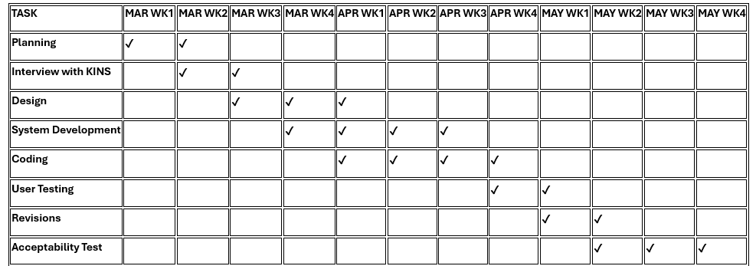

*Figure Data 13 Schedule Feasibility*

**Economic Feasibility**

The proposed system is economically feasible as it does not require the purchase of new equipment, hardware, or software. The university can implement the system using existing resources, making it a cost-effective solution. By transitioning to a paperless system, the management will save money on printing costs, paper, and energy, as all transactions and records will be handled digitally. This reduction in paper usage will not only lower operational costs but also contribute to environmental sustainability. The system’s implementation is therefore a financially sound investment that offers long-term savings for the university.

**Requirements Modeling**

**Input**

The development of the Website Dashboard is driven by input from HR personnel and employees regarding the current challenges in data management and leave tracking. Interviews and observations helped identify key issues and requirements, which were then used to shape the system’s design. This input ensures that the dashboard addresses the real needs of both administrators and employees, making data management more efficient and accessible.

**Process**

The Website Dashboard process begins with real-time data monitoring and interaction, where users can input, update, and access key metrics and activity logs. Administrators will oversee the system, managing user roles, approving updates, and ensuring data accuracy and integrity. Employees will be able to view their leave status and performance metrics, while the approval system will ensure transparency and accountability for every update. This process allows for seamless collaboration, streamlined workflows, and efficient decision-making across the organization.

**Output**

The Website Dashboard enables administrators to efficiently manage and monitor employee data, including tracking activity logs and key metrics. Administrators can verify, post, and review updates, while also managing user roles and access to the system. For employees, the dashboard provides a clear view of their leave status, performance metrics, and relevant data updates. The system will output real-time information, ensuring that both employees and administrators can make informed decisions quickly, with clear visibility into the approval status and other key data points.

**Control**

The Website Dashboard provides administrators with full control over key aspects of data management. Administrators can oversee the approval process, manage user roles and permissions, and control access to sensitive information. They will be able to post, review, and verify data, as well as track and manage updates. The system will also allow customization based on user roles, ensuring that employees and administrators can access only the relevant data. This control system will ensure that data integrity is maintained, workflows are streamlined, and transparency and accountability are enhanced throughout the organization.

**Performance**

The Website Dashboard is designed to perform efficiently in managing and monitoring real-time data. With a dynamic and responsive interface, the system ensures seamless integration with external databases, providing up-to-date and accurate information. It allows users to easily post, review, and verify data, such as activity logs and key metrics, while maintaining a structured approval process for consistency and transparency. The dashboard’s performance will be optimized for fast data access and processing, ensuring that users can track performance, identify trends, and make informed decisions quickly. This performance-driven approach enhances operational efficiency, data integrity, and collaboration across the organization.

**Modeling**

The scope of this project is centered on creating a platform for real-time data monitoring, management, and interaction. It involves processes like tracking performance metrics, managing activity logs, and verifying data updates. The system will allow staff and administrators to interact with data seamlessly, using an intuitive and customizable interface. The dashboard will integrate with external databases, ensuring that the data is always up-to-date and accurate. By incorporating a structured approval system, the project will improve data consistency, transparency, and accountability. This model supports better collaboration, informed decision-making, and enhanced operational efficiency, making the system essential for streamlining workflows and fostering a well-informed organization.

**System Architecture**

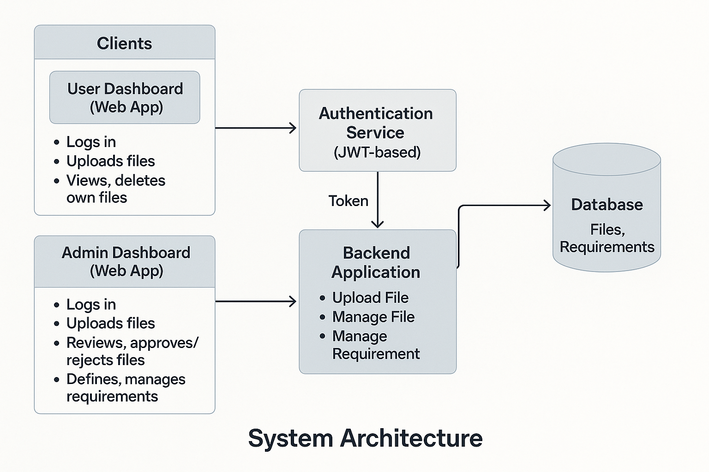

*Figure14 System Flow*

This architecture allows building a strong, secure and scalable storage device for files that offers differentiated access controls to users and administrators. Implementing JWT-based authentication and backend processing non-limiting allows for getting the best of all worlds regarding data safety and efficiency. It is therefore suitable for deployment in learning or working environments and in compliance driven environments.

**Network Model**

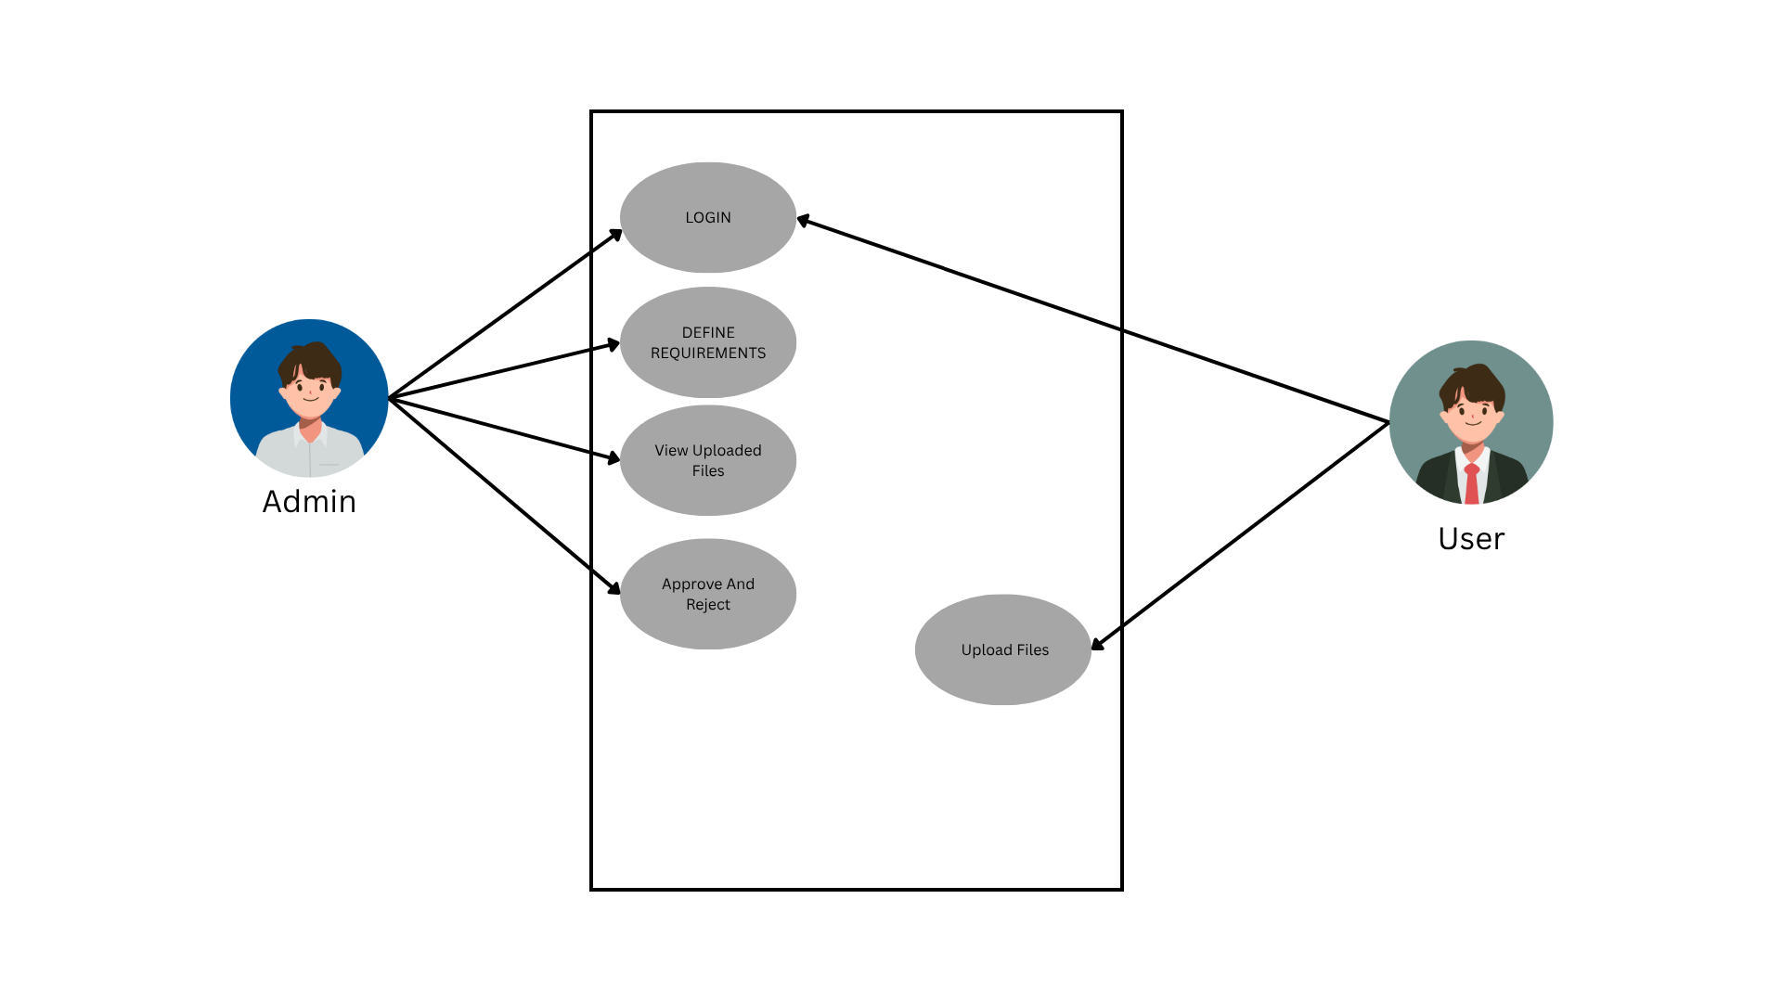

*Figure 15 UML Diagram*

This UML Use Case Diagram shows the functional element of interactions between two primary actors, namely, the Admin and the User, and key operations offered in a file management system. It demonstrates the obligations and allowances of every actor of this system confirming role-based rules of the access control to the system.

**Network Topology**

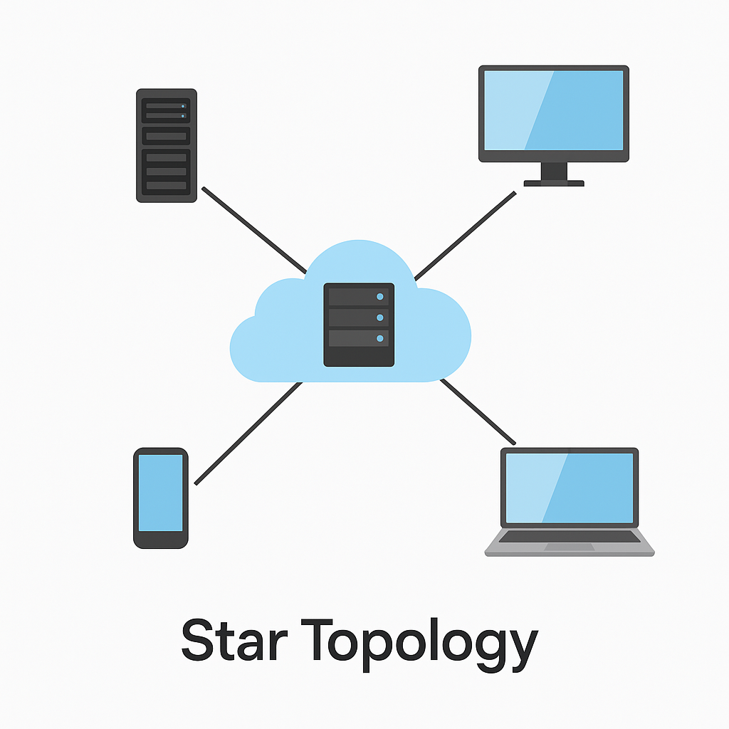

*Figure 16 Network Topology*

The system is set to function effectively within WAN and LAN settings using a star topology. In the middle of the network, there is the central server that directly communicates with the various client machines such as Laptop, Desktop and mobile phone. Such clients communicate via a central hub/switch thereby having organized traffic and easy management. Hosting the server on the university’s domain permits remote access using the internet. Implementing the three-tier architecture inside the star topology improves reliability and maintainability of the system. This architecture allows for a rapid and scalable delivery, and the client devices communicate with the system via the presentation layer.

**Security**

**1. System Security.** The Website Dashboard features strong security, restricting admin page access to administrators only. It uses encrypted passwords to protect user data, ensuring privacy and data integrity even if files are accessed by unauthorized users.

**2**.**Data Reliability and Integrity.** The Website Dashboard ensures data reliability and integrity by using a secure database for accurate data storage. Validation and approval workflows prevent errors, while encryption and regular backups protect and maintain data integrity.

**3.Log-In.** The only person who can manage the system is the administrator and can create user accounts.

**4. Database.** The system will have a database for the storage of data in order to maintain the integrity of the data. The database will be online making it easy to be accessed by the administrator anywhere.

**Development Plan**

The system will be developed using the **Agile methodology**, which focuses on iterative development, collaboration, and flexibility in response to changing requirements. Interviews with HR personnel and employees will be conducted to gather the necessary requirements for the system. The development process will be broken down into smaller, manageable iterations or sprints, allowing for continuous feedback and improvement. For front-end development, HTM5, CSS, and JavaScript will be used, with Vite as the build tool for fast and optimized development. The backend will be built using Node.js, and MongoDB will be utilized for the database to ensure efficient data management. The system will be run on a suitable localhost server environment during development. Visual Studio Code will be used as the text editor throughout the project. This approach ensures a flexible, collaborative, and efficient development process, allowing the system to evolve based on user needs and feedback.

**Deployment Diagram**

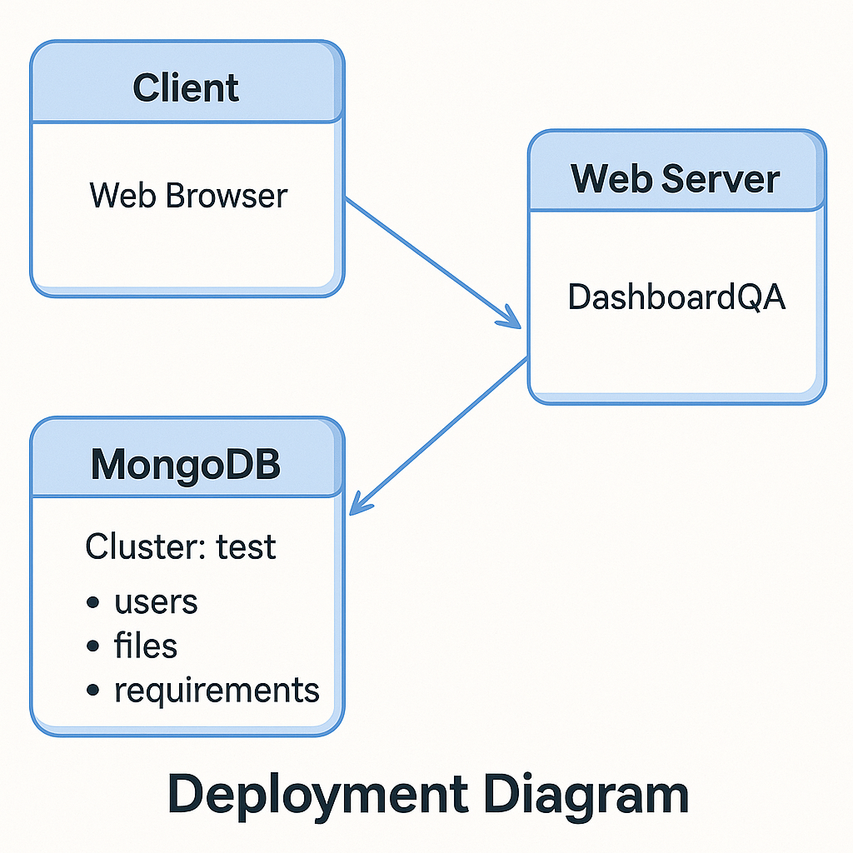

*Figure 17 Deployment Diagram*

This deployment diagram depicts the physical architecture of the file management system, where the system depicts how various software components are deployed in several hardware and infrastructure levels. The system uses the three-tier architecture arrangement Client, Web Server, and Database (MongoDB); in this arrangement, scalability, modularity, and security in data management are guaranteed.

**Test Plan**

This test plan focuses on verifying the core features of the QA Dashboard system. The main goal is to ensure that both user and admin functionalities perform correctly and handle valid and invalid inputs as expected. Testing will cover registration, login, requirement creation, file/URL submissions, and admin actions such as approval, rejection, and deletion.

Testing will follow a manual approach, using predefined test cases. Each test case will also include a feature, description, and expected result to validate system behavior, Functional testing will be conducted for both user-side and admin-side features to ensure system reliability and proper flow of data.

**Unit testing**

|  |  |  |  |
| --- | --- | --- | --- |
| Test Case ID | Feature | Test Description | Expected Result |
| TC01 | Register | User registers with valid input | Account is created |
| TC02 | Register | User registers with missing input | Registration is rejected with error |
| TC03 | Login | User logs in with correct credentials | Redirected to dashboard |
| TC04 | Login | User logs in with wrong credentials | Login fails with error message |
| TC05 | Requirement Creation | Admin creates a requirement | Requirement is saved |
| TC06 | File Upload | User uploads a file | File is saved |
| TC07 | URL Submission | User submits a URL | URL is saved |
| TC08 | Approve Submission | Admin approves a submitted file or URL | Status updates to “Approved” |
| TC09 | Reject Submission | Admin rejects a submitted file or URL | Status updates to “Rejected” |
| TC10 | Delete Submission | Admin deletes a submitted file or URL | Submission is removed |

**References**

* Baker, R. S., & Inventado, P. S. (2014). Educational data mining and learning analytics. In R. K. Sawyer (Ed.), *Cambridge handbook of the learning sciences* (2nd ed., pp. 589–606). Cambridge University Press.
* Daniel, J. (2012). Making sense of MOOCs: Musings in a maze of myth, paradox, and possibility. *Journal of Interactive Media in Education*, *2012*(3), Article 18. https://doi.org/10.5334/2012-18
* Ferguson, R. (2012). The state of learning analytics in 2012: A review and future challenges (Technical Report KMI-12-01). Knowledge Media Institute, The Open University.
* Nielsen, J. (1994). Enhancing the explanatory power of usability heuristics. In *Proceedings of the SIGCHI Conference on Human Factors in Computing Systems* (pp. 152–158). https://doi.org/10.1145/191666.191729
* Norman, D. A. (2013). *The design of everyday things* (Rev. & expanded ed.). Basic Books.
* Piety, P. J. (2013). *Assessing the educational data movement*. Teachers College Press.
* Romero, C., & Ventura, S. (2020). Educational data mining: A review of the state of the art. *IEEE Transactions on Systems, Man, and Cybernetics: Systems*, *50*(3), 518–539. https://doi.org/10.1109/TSMC.2019.2905097
* Siemens, G., & Long, P. (2011). Penetrating the fog: Analytics in learning and education. *EDUCAUSE Review*, *46*(5), 30–40.
* United Nations. (2015). *Transforming our world: The 2030 agenda for sustainable development*.<https://sdgs.un.org/goals>
* Verbert, K., Duval, E., Klerkx, J., Govaerts, S., & Santos, J. L. (2013). Learning analytics dashboard applications. *American Behavioral Scientist*, *57*(10), 1500–1509. https://doi.org/10.1177/0002764213479363
* Yassine, M., Kadry, S., & Sicilia, M. A. (2016). A framework for learning analytics in Moodle for assessing course outcomes. *Computers in Human Behavior*, *61*, 588–597. https://doi.org/10.1016/j.chb.2016.03.052